Briefing Paper
To
Overview and Scrutiny Committee (Community and Services)
On
16 March 2021
TENANCY SERVICES UPDATE

1. SUMMARY

This briefing paper gives Overview and Scrutiny Committee (Community and Services) a summarised up-date on specific areas of activity within Tenancy Services

2. BACKGROUND

This paper up-dates members on the following areas:

- The number of tenants on Universal Credit and the impact on rent arrears
- Overall levels of current tenant arrears
- Levels of anti-social behaviour

3. UNIVERSAL CREDIT

3.1 The payment of Universal Credit (UC) continues to be rolled out across the Mansfield district. As at 5 March 2021 the council had 1,491 tenants in receipt of UC with approximately 15-20 new cases transferring over from legacy benefits each week.

3.2 UC was introduced with the aim of preparing claimants for the work environment in which 75% of employees are paid monthly, whilst at the same time encouraging tenants to take responsibility for their own financial affairs. It is paid as a single monthly sum and households are expected to manage their own budgets including payment of their rent.

3.3 Where there is a history of rent arrears or the tenant is considered to be vulnerable with issues such as mental health, drug or alcohol dependency, then it is possible for the council to claim the rent element of a households UC, direct from the Department of Work and Pensions (DWP). This is called a managed payment. Under normal circumstances it is not possible to claim this until after the claimant has received their first payment, which results in the tenant falling further into arrears.

3.4 Of the 1,491 tenants on UC the council has applied for 792 managed payments, representing approximately 53% of all tenants receiving UC. In addition the council is in receipt of 337 payments of arrears direct from UC, representing 22% of all tenants on UC.

3.5 A breakdown of the arrears data shows that of the 1491 tenants claiming UC:-

- 448 have rent arrears of between £100 - £499
- 156 have rent arrears of between £500 - £999
- 182 have rent arrears above £1,000

The total outstanding rent arrears for all 1,491 UC claimants is £575,344

3.6 Not all of the £575,344 can however be attributed directly to UC as many of the tenants were in rent arrears prior to transferring onto UC.

3.7 It is difficult to accurately quantify what impact UC has had on arrears levels as we are not always immediately notified when a tenant is due to transfer benefits. Indeed if a tenant pays their own housing costs direct from their UC payment, we may not know for several weeks or months that they have transferred onto UC. Analysis of rent arrears figures, from dates associated with when the council was first notified tenants were transferring to UC would however suggest, total current tenant rent arrears, at the time of transfer was £545,164

3.8 A simple estimate of the direct impact of UC on rent arrears would therefore be to subtract the estimated figure of £545,164 from the 5 March 2021 figure of £575,344 which would suggest increased UC arrears of £30,180. Obviously a caveat needs to be placed on this figure as a proportion of the tenants would not have been on full housing benefit and would not have paid their rent and arrears, even if they had stayed on legacy benefits.

4.0 OVERALL LEVEL OF CURRENT TENANT ARREARS

4.1 The total of all outstanding arrears as at 5 March 2021 was £1,027,169 inclusive of the debt associated with UC. The figures show that the level of debt associated with tenants claiming UC represents 56% of all outstanding current tenant arrears.

4.2 The total of all outstanding current tenant arrears for the corresponding period 6 March 2020 was £1,016,850 an increase of £10,319. This represents an increase of approximately 1% on the 12 month period.

4.3 The table below illustrates the level of current tenant arrears over the last 2 financial years. It can be seen that there is a direct pattern across the 2 year period.

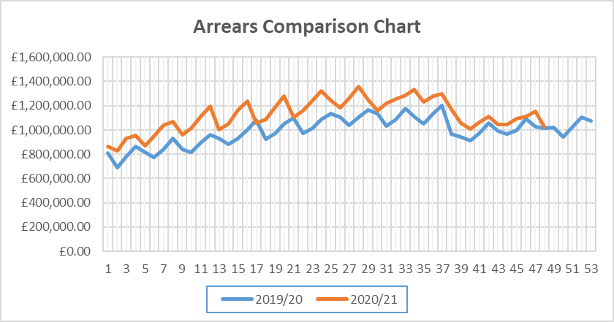

4.4 Due to central government Covid 19 regulations, placing restrictions on the council taking enforcement action, only 1 eviction for rent arrears has been carried out during this financial year. For comparative purposes at the same point in time last year the council had undertaken 26 evictions when arrears had been cited in full or in part on the court application.

4.5 Income Officers in conjunction with Financial Inclusion officers continue to work with tenants at the earliest possible opportunity, to resolve issues of both rent arrears and in helping them maximise their income through benefit entitlements. Enforcement action through the courts will always be seen as a last resort, when the tenant has failed to engage and all others options have been explored.

5. LEVELS OF ANTI-SOCIAL BEHAVIOUR

5.1 The housing department currently has 548 ongoing cases of ASB which it is investigating. In addition a further 304 cases have been closed within this financial year with 273, approximately 90% of those, having a successful resolution.

5.2 The lower level cases of ASB are investigated by the Housing Management Officers with the more complex cases, especially those involving criminal activity are investigated by the Specialist ASB and Tenancy Enforcement Officers.

5.3 Initial investigations include home visits, telephone calls, emails letters etc. which often resolves the issue, without the need to take formal legal action, even if this does sometimes take a protracted amount of time. Where this approach doesn’t work a variety of methods can be used to try and help resolve the situation and this financial year the following actions have been taken:-
- 2 suspended possession orders have been granted
- 6 injunctions have been obtained
- 13 Notices of Seeking Possession have been served
- 27 Community Protection Warnings/Notices have been served
- 2 tenants gave up possession of their property to avoid court action

5.4 The list below, with redacted addresses, gives an indication of the type of complaint the department is currently dealing with and the action being taken.

- Park Hall Ward – Noise, threats to neighbours, threats to property, criminal damage. Notice of seeking possession has been served and in addition an injunction has been applied for and has been granted. The injunction has now been breached and a committal to prison application is being made.
- Sherwood Ward – threats to neighbours, noise and alcohol related issues. Notice of seeking possession has been served. The tenant contesting our possession application and we are awaiting a trial date for a possession hearing.
- Bull Farm/Pleasley Hill – criminal damage to property on several occasions. Notice of seeking possession has been served, awaiting trial date. Pre-trial hearing set for 11 March 2021
- Abbott Ward – General ASB plus burgled neighbour. Eviction set for 9 March 2021
- Oak Tree Ward – children generally causing a nuisance on the estate including some criminal activity. Notice of seeking possession has been served and a full possession hearing is now being sought. Directions hearing at court stated this will not be until after 21 June 2021
- Park Hall Ward – mainly noise related activity, loud music, criminal damage to property, and the police are in regular attendance. Notice of seeking possession has been served and in addition an injunction has been applied for and granted. A committal to prison application is now being made due to breach of the injunction.
- Penniment Ward – general neighbour nuisance, alleged criminal and drug related activity at the property. Notice of seeking possession has been served and paperwork is now being prepared for a full possession application to be made.
- Newgate Ward – criminal damage, abusing neighbours, children being allowed in block to cause ASB. Notice of seeking possession has been served and paperwork is now being prepared for a full possession application to be made.
- Newgate Ward – noise related issues, domestic violence, alcohol issues. This is an introductory tenancy and a Notice of Possession Proceedings was served, which was withdrawn on a formal appeal being made. Within 48 hours problems re-surfaced and a new Notice of Possession Proceedings will be issued. As this is an introductory tenancy when the case goes to court, possession will be mandatory.

6. BUDGET / RESOURCE IMPLICATIONS

Any costs associated with the content of this briefing paper are being met from existing Housing Revenue Account budgets and staffing resources.

7. COMMENTS OF HEAD OF SERVICE

The Covid-19 pandemic has been a challenging time for the Housing Management service in terms of managing rent arrears and anti-social behaviour. The implementation of introductory tenancies earlier in 2020 will be a positive step forwards in terms of our ability to effectively manage anti-social behaviour and rent arrears in the future. The service continues to provide a range of support offers to those tenants that are struggling to pay their rent including debt and welfare advice and this forms a key part of the council’s new Homeless Prevention Strategy.

Report Author | - | Neil Turton
Designation | - | Tenancy Services Manager
Telephone | - | 01623 463741
E-mail | - | nturton@mansfield.gov.uk

